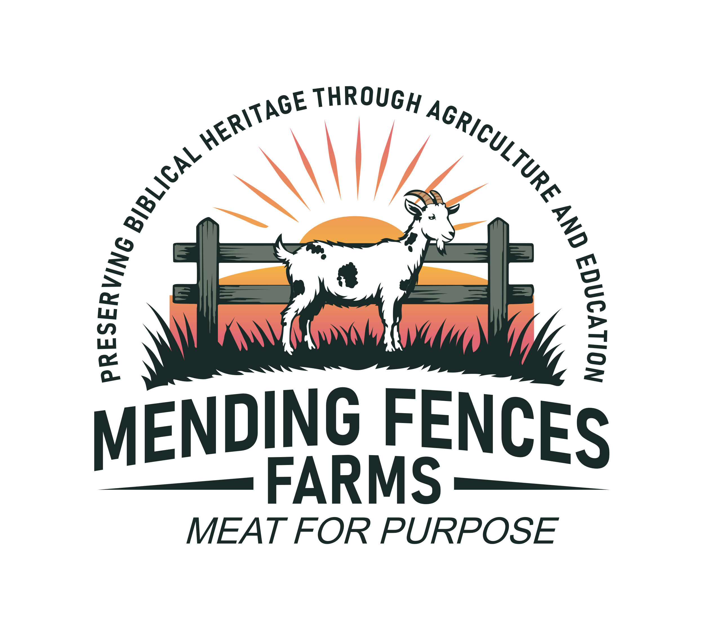
Mending Fences Farms Participant Waiver

Section I. Animals
I understand that the behavior and actions of any animal can be unpredictable and that in working with animals, personal injury or property damage may occur. Being aware of the risks that may be involved, I indemnify and hold harmless Mending Fences Farms and/or their owners, volunteers, officers and employees for any and all personal injury or property damage resulting from my participation.
Section II. Photography
I understand that photographs, pictures, slides, movies, or videos may be taken of me and my guest in connection with my participation in farm activities, and that these pictures may be used on the Mending Fences Farms website, posted on Facebook, or other social media sites.
Section III. Conduct and Behavior
I agree to obey all posted signs and safety rules and to alert the staff to any rules violations or dangerous behavior of co-participants. I agree to stay in areas to which I am assigned and not enter areas that will place me in undue danger. As an adult, I will supervise my child(ren) at all times. Participation is solely at the discretion of the owners and staff members of the farm. I will always be accompanied by a Volunteer or a member of the staff or owners that are educated and versed in goat herd management, farm rules and regulations and principles. I will follow their direction and keep the safety of others and the herd in mind when I take action.
Section IV. Hand Sanitation
Interaction with farm animals is an important experience for children and adults. Being able to touch and watch the animals helps people to learn about agriculture. Despite the many benefits of interacting with farm animals, people should be aware that farms animals can sometimes carry germs that make people sick. I will protect myself, my family, and the animals on the farm by remembering to use hand sanitizer after contact with farm animals.
Please Review this form before signing

Full Name: ___________________________________________________________

Email: __________________________________________________________________________

Phone: __________________________________________________________________________

Names of additional minors I am signing for:

____________________________________________________________________________________________________________________________________________________________________________________________________________________________________________________________________________________________________________________________________________________________________________________________________________________________________

I confirm that I am over 18 years of age. I have read and unconditionally agree with the farm waiver as written.

Signature of Parent/Legal Guardian/Participant:

____________________________________________________________ Date:___________________

